Artist Name: Jeff Elbel + Ping Publicity photos, articles, lyrics, etc.: marathonrecords.com/ping/press.html
Album Title: The Eleventh Hour Storybook Management: Jeffrey Kothoff * (630) 926-3480 * jeffrey@lo-fidelity.com
UPC: 610987 18122 9 Booking: Monica Doyle * (630) 260-5937 * booking@marathonrecords.com
Retail Price: $11.99 - Early bird Price Point: $9.99!

Available from Marathon Records (www.marathonrecords.com) in cooperation with Lo-Fidelity Records (www.lo-fidelity.com)
Telephone: (847) 330-2514 or (630) 682-3903. E-mail: info@marathonrecords.com

01 Engine of Destruction
02 You Little Victim
03 Bark Along with Cody
04 Goodnight, Rabbit
05 Getting Ahead of Myself
06 All in All
07 Muffin in the Oven
08 Soul Destroyer
09 Sing it Out Loud
10 Time to Leave

Key Selling Points:
*Loyal audience for current and prior Elbel-related projects
*Well-known to other artists' fan bases via collaboration
and live/studio session performances
*Performing major summer festival dates
*Rock radio promotion; featured on Dr. Demento Show
*Heavy Internet promotion
*National advertisement in print media
*Popular writer for Big Takeover, Paste, Mean Street
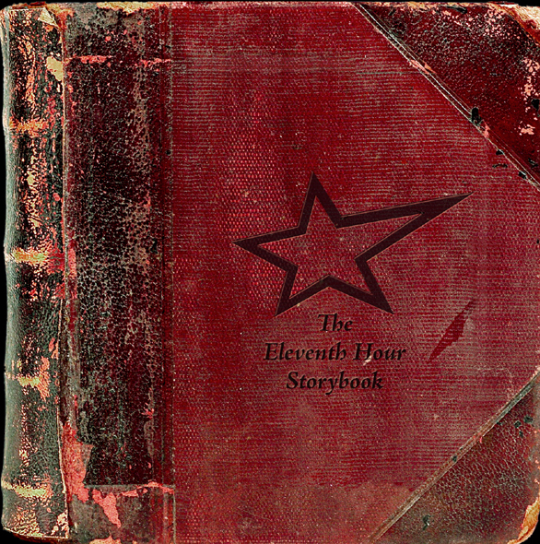

Album Description:
The Eleventh Hour Storybook contains ten tracks of fully amped rock and roll storytelling, with an emphasis on good fun and embracing the challenges of real life. The album is suitable to rock all ages, from hip kids to veterans alike. The whimsical "Bark Along with Cody" and "Muffin in the Oven" have been featured on The Dr. Demento Show. Ace guitarists Andrew Carter (Andrewesley) and John Bretzlaff cut loose on a Stonesy examination of married life called "Goodnight, Rabbit." Hammond B3 maestro Phil Madeira (Buddy Miller, Emmylou Harris) guests on several cuts, including the Subterranean Homesick pop of "You Little Victim" and a freewheeling tale of exhilarating chaos called "Engine of Destruction." Mastering performed by Dan Stout (Wilco, etc.). Proceeds will benefit Habitat for Humanity.

Music Genre: Rock and Roll
Recommended If You Like (RIYL): Cake, Rolling Stones, Wilco, Adam Again, Kinks, They Might Be Giants, Big Star
Tours & Performance: Annual Midwest tour incl. club & festival dates. West Coast dates from So Cal to SW Canada
Shared bills with: Over the Rhine, The Alarm, Starflyer 59, the 77s, the Violet Burning, the Lost Dogs, the Autumns,
Vigilantes of Love, Woven Hand, the Lassie Foundation, Andrewesley, John Davis of Superdrag, & many more.
Live/session credits: Rick Altizer, Aaron Sprinkle, the Lost Dogs, Miranda Stone, Jason Harrod, Blackball, EDL,
the Wayside, Chris Taylor (Love Coma, the Notorious Sinners), Andrewesley, LSU, Jan Krist, Brooks Williams,
Phil Madeira
Awards: 2003 Indie Acoustic Project Awards: Top Five - Best Independent Album (Jeff Elbel + Ping's No Outlet)
Artist’s Hometown: Wheaton, IL (Chicago area, with roots in Champaign, IL and Los Angeles, CA)

Discography (selected titles; Jeff's own albums in bold):
Echoes of Laughter (Farewell to Juliet) 1993 Marathon Records
Bloomshine! (Sunny Day Roses) 1996 Marathon Records
Hope (Blackball) 1997 Metro One Records
Grace and Dire Circumstances (Farewell to Juliet) 1998 Marathon Records
Dogfish Jones (LSU) 1998 Platinum Entertainment
Ford Supersonic (Aunt Bettys) 1999 Marathon Records
Moment of Clarity (Every Day Life) 1999 KMG Records
No Outlet (Jeff Elbel + Ping) 2001 Marathon Records
Making God Smile (various artists) 2002 Silent Planet Records
Bring in the Sun (the Hopescope) 2003 Marathon Records
Saving Grace (Dead Artist Syndrome) 2003 Galaxy 21
Loyal to You (Jeff Elbel + Ping) 2003 Marathon Records
Engine of Destruction (Jeff Elbel + Ping) 2004 Creation Station
Strength (Andrewesley) 2004 Marathon Records

